**Presenting**

**Project**

**On**

**Foundation of SQL**

**By:**

**DHOTRE SHWETA GANESH**

**(Master’s in Data Science)**

**Institute: ITVEDANT**

**Branch: Vashi**

**Email:** [**shwetapawar1811@gmail.com**](mailto:shwetapawar1811@gmail.com)

**Professor:- Akansha Rane**

**19 november 2022**

**Abstract:**

Student information system helps us to get College details and Teacher and student ,dept ,salary ,grade,marks name , course fees are easily available for information purpose.This data is the most important thing in any organization and so it must be protected by malicious intended users.

1. **What is sql?**

**Sql is structured query language ,which is used to communicate with database .**

1. **Why sql used?**

**Sql is mainly used for storing and retrieving data from database, but it can do much more than that .Anything you want to do with database , you can do with sql.it is flexible , powerful ,and quick while being accessible and affordable for most businesses.**

1. **Create database with name college.**
2. **Create table name teacher which has tid,firstname,lastname,dept,sallary,color.**

**Create table teacher(tid int primary key not null ,firstname**

**varchar(255),lastname varchar(255) , dept varchar(255), sallary int ,color int)**

**5.show the structure of table student with inserting values**

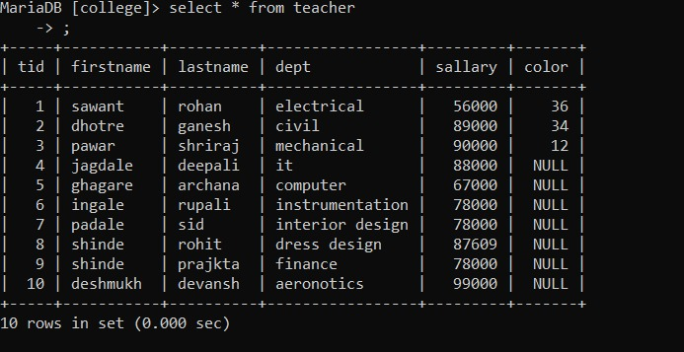

**5.display firstname ,dept, sallary from teacher**

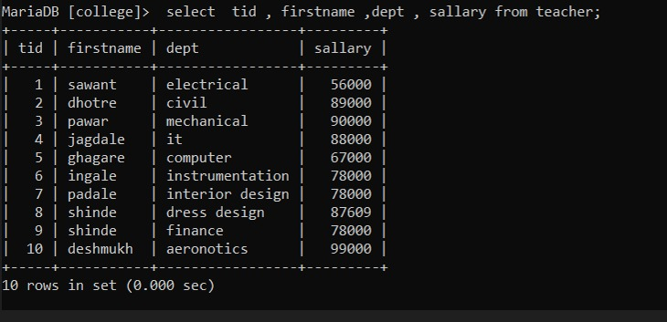

1. **Create table name teacher with reference of table teacher ,insert values in it .**

**Create table stud (sid int primary key ,firstname varchar(255),lastename varchar(255),fees int , grade varchar(255),marks int , tid int ,foreign key (tid) references teacher(tid);**

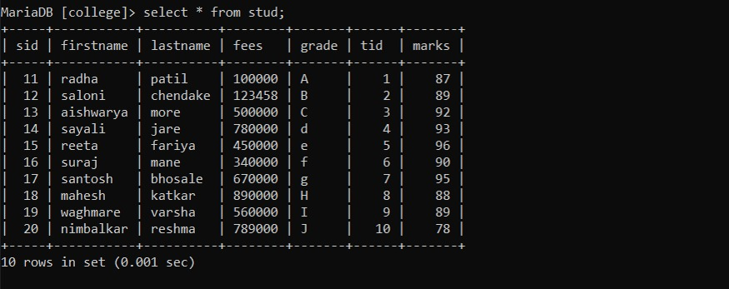

**6.delete row from stud whose sallary is less than equal to 500000.**

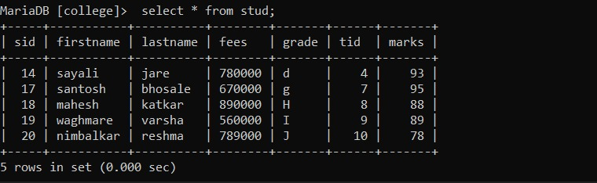

1. **Add column grade in table teacher.**

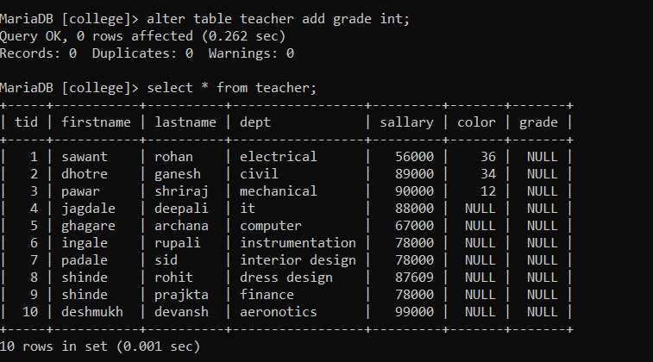

1. **Display data Inserted in column grade for first 5 id.**

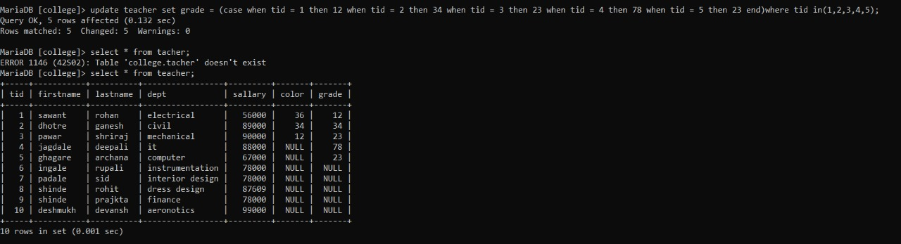

**8.update the firstname from teacher where dept is aeronotics.**

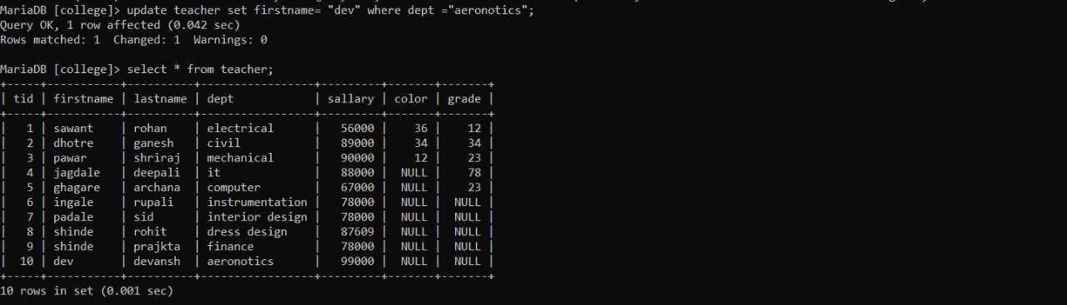

**9.display sum of sallary from table**

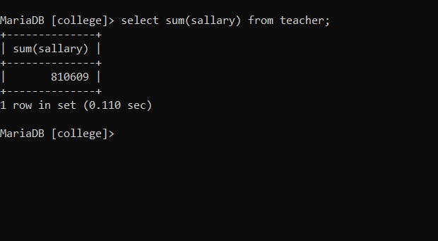

**10.select count from table teacher .**

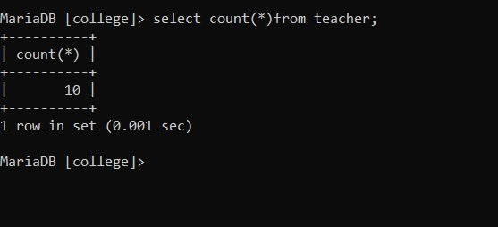

**11. display the sallary in ascending order**

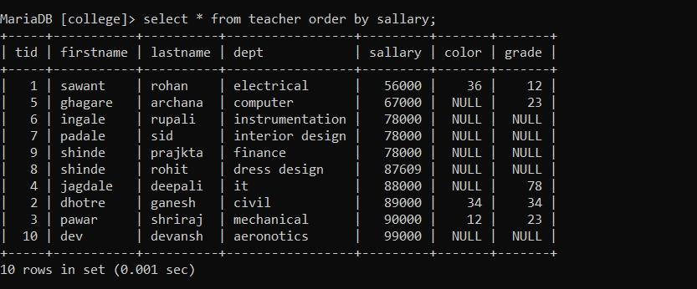

**12.dispaly the distinct value in column id from table teacher**

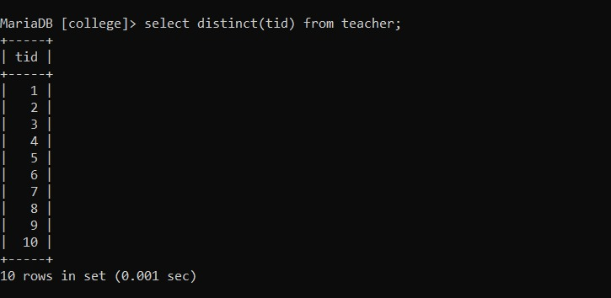

**13.like operator :used to search specified pattern**

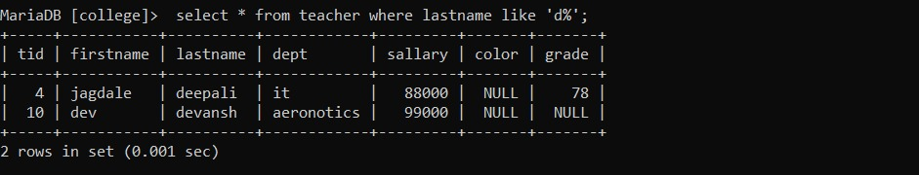

**14. not like**

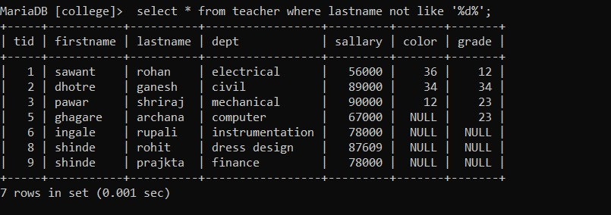

**15 between – selects a range of data between two values**

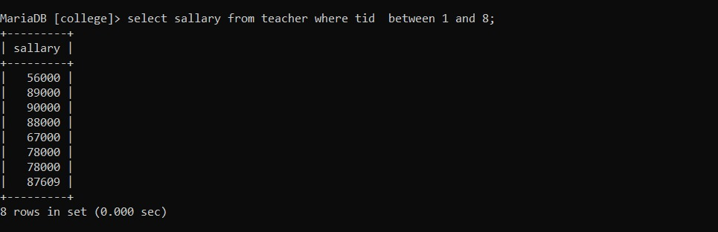

**16.alias – you can give another name to table or column by using alias**

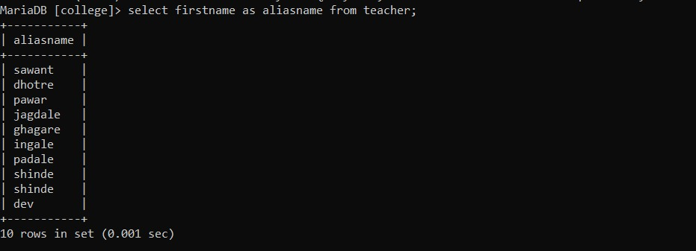

**17. inner join**

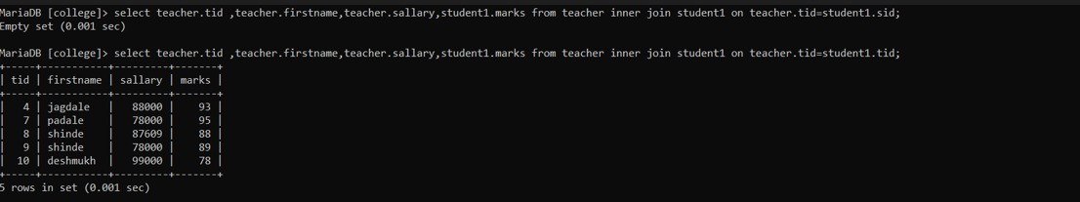

**18. right outer join**

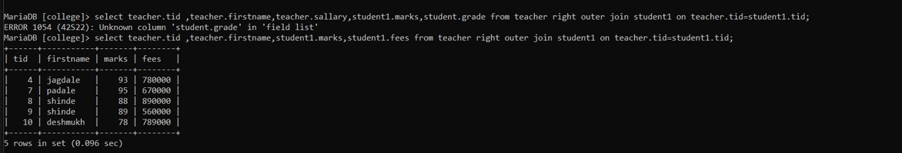

**19 . left outer join**

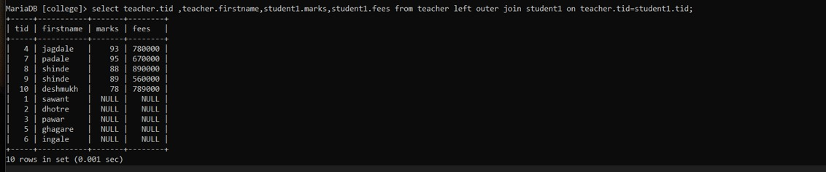

**20 . Full outer join**

**21 . view**

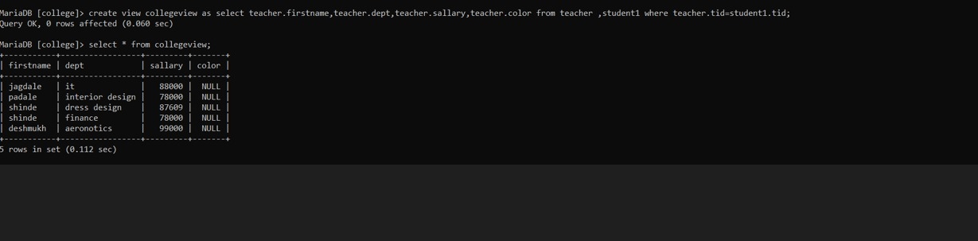

**22. avg**

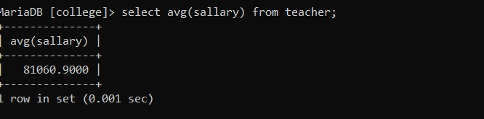

**23. concat**

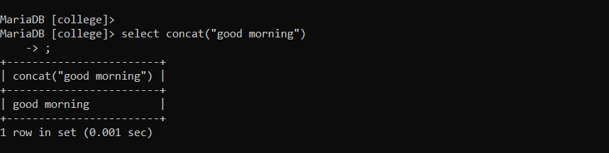

**24..lowercase**

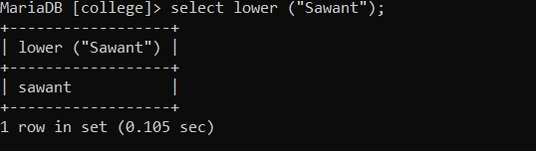

**25.uppercase** ..

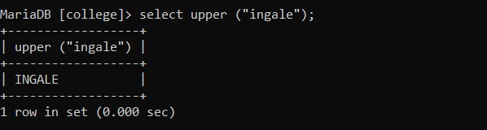

**26. ascii-**

**Ascii function returns the ascii value for specific character.**

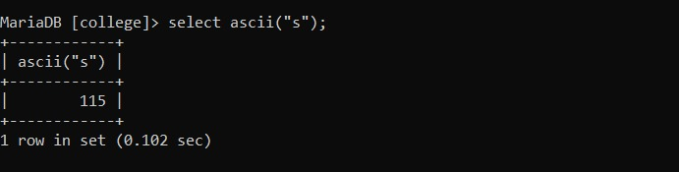

**27. length – find out length of character**

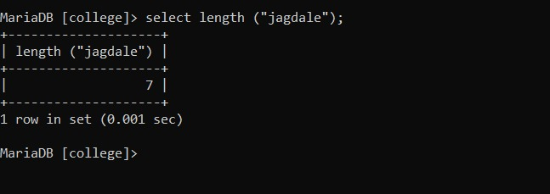

**28 change the name of table teacher**

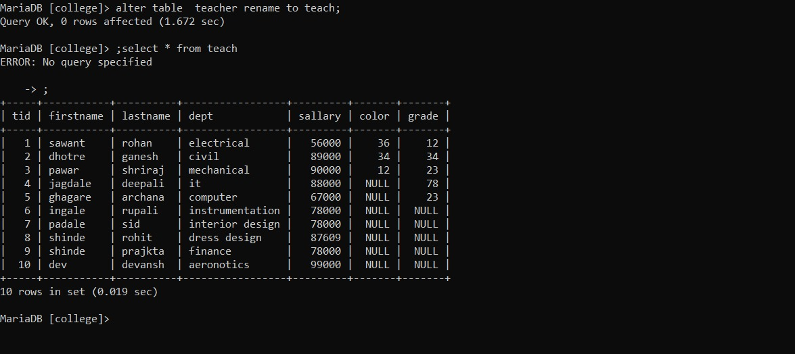

**29. substring**

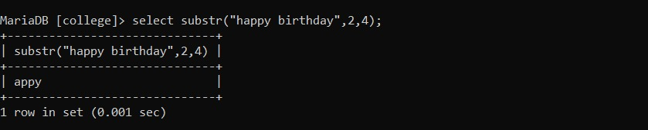

**30. replace**

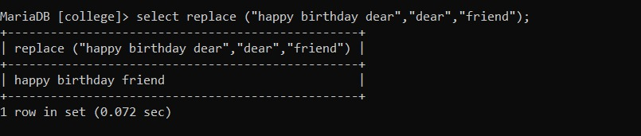

**CONCLUSION :**

**HEREBY I CONCLUDED I HAVE DONE MY SQL PROJECT AND ACHIEVED MY**

**AIM BY PERFORMING ALL SQL QUERIES TO BEST OF MY KNOWLEDGE.**